Integrated Graphics Development Tool (IGDT)

User Manual

Revision History
Date | Version | Description | Author
03/09/2016 | 1.0 | Initial draft | Shekar/Sathish
17/07/2017 | 1.1 | Updated for Mono platform | Karthik

Table of Contents

1. Introduction 3
1.1 Overview 3
1.2 Supported Platforms: 3
1.3 Pre-requisites 4
1.4 Run Application 4
2. Getting Started 4
2.1 GUI 5
2.2 Project Menu 6
2.3 Add: 7
2.4 View 7
2.5 Help tab 7
2.6 Language 8
2.7 Generate Layer Usage Report: 9
2.8 Element: 9
2.9 Highlight: 9
2.10 Search: 11
2.11 Clear List: 11
2.12 Mode: 11
2.13 Zoom +/ Zoom – 11
2.14 Toggle View 11
3. Project Settings 12
3.1 Layers: (Layer Configuration) 12
3.2 CodeGenOptions1 13
3.3 Language Options 16
3.4 Theme 17
3.5 Create And Save 17
4. Designing of Elements 18
4.1 Font Element 18
4.2 Font Group 22
4.3 Screen Element 23
4.4 Widget Element: 26
4.4.1 OpenVG Property Tab 29
4.5 Image Element 31
4.6 Text Element 34
4.7 Fill Screen Element 40
4.8 Animations 42
4.9 Language Menus 51
4.10 Language Support 52
4.11 Using SID’s in Text 53
5. Other 54
5.1 Grouping Elements 54
5.2 Dynamic Image 55
5.3 Selecting Rotation Types 55
5.4 Text Rendering 57
6. Platform Specific - Kepler2 (Pt_Amber): 58
6.1 Layer Configuration: 58
6.2 Design Rules:- 60

Introduction

1.1 Overview

IGDT – Integrated Graphics Design Tool provides raster and vector based graphics display design and code generation functionality. IGDT tool is a complete package which includes authoring tools, simulator and programming. Design the screens as per requirements and generate the code. We can design GUI for the below supported platforms.

Supported Platforms:

- DCU - Kepler1
- DCU_Lite
- OpenVG
- Software
- OpenGL
- Fujitsu
- Amber – Kepler2
- Mono (1/2/4bpp)

Pre-requisites

C/C++ Programming Language and XML

1.4 Run Application

Once downloaded the workspace UI_CORE_GDT_DEV_Eng stream from RTC, please find the zip file gfx_mgr02_gdt.zip from below directory and unzip it.
..\..\ui-core-gdt\ui.core.gdt.doc\hmi.gfx.manager.02\release
\gfx_mgr02_gdt.zip

Access the IGDT application as below.

..\..\ui-core-gdt\ui.core.gdt.doc\hmi.gfx.manager.02\release
\gfx_mgr02_gdt\gfx_viewer_win32.exe

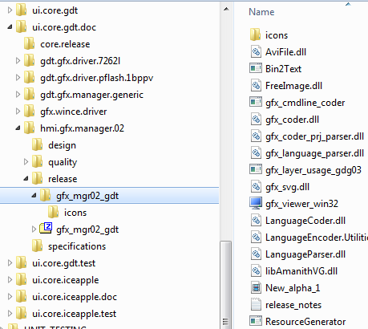

Getting Started

GUI
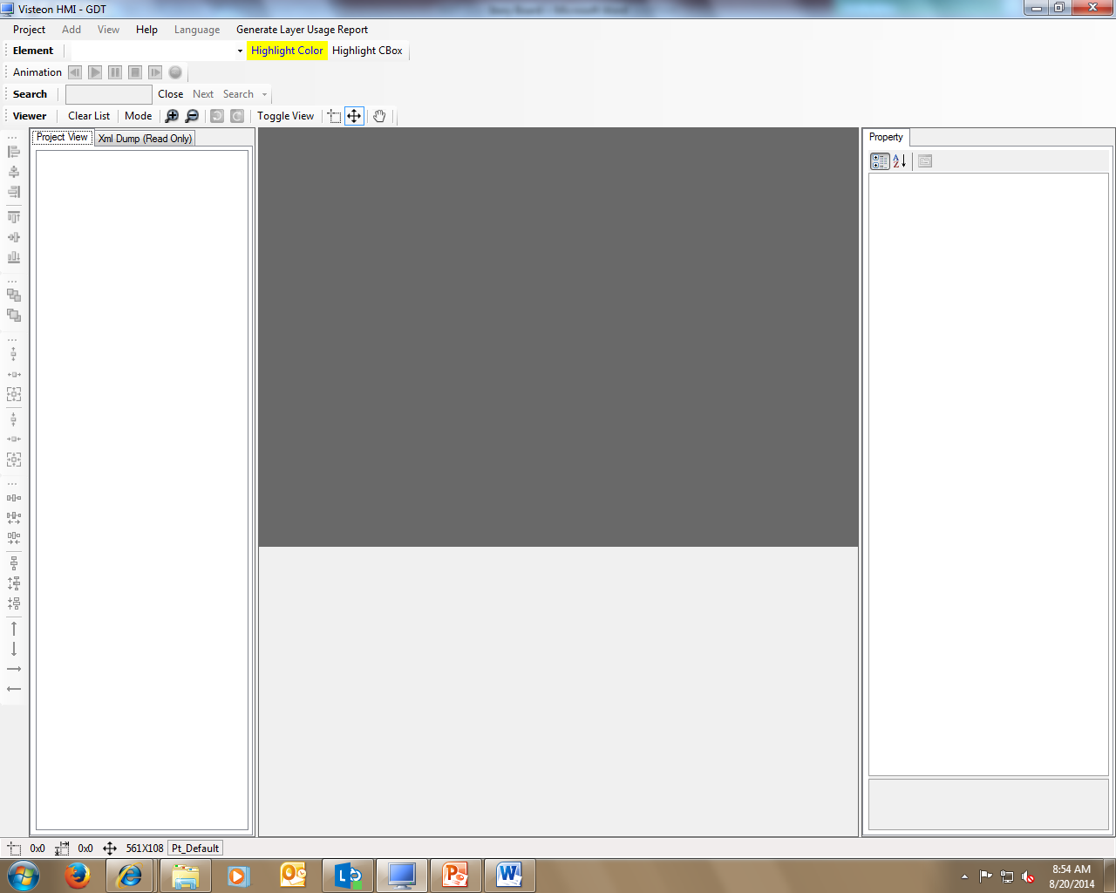

- Project Menu View– New, Open, Save, Save As, Close, Import, Project Setting, Generate All, Generate Image data, Generate Config.dat, Generate Font data, Generate Language data, Generate Animation Data, Exit
- Project Tree View – Arrange the Elements into: Screens, Widgets, Tests, Images, Fill_Screens, Font, Animations, Language Menus
- Property Grid View –Element(Screen/Text/widget/Fill Screen) Properties showing on right side of viewer
- Content Based Tool – Alignment, Arrange Build Order, Adjust XY Location, and Adjust Fill Area
- Status Bar – Shows XY location of element.

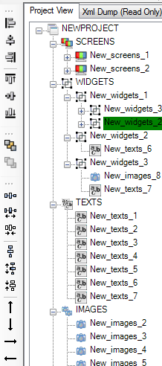
Move up by one pixel
Move down
Move right
Move Left

Make equal horizontal spacing
Increase horizontal space
Decrease horizontal space
Make equal vertical spacing
Increase Vertical space
Decrease vertical space
Bring Forward once
In Tree view
Move one level to back
Align Left
Align center
Align right
Align Top
Align Middle
Align down

Project Menu

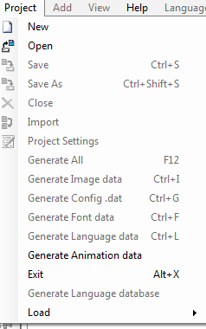

- New: To design a New Project and Opens the new Project Settings dialog box for configuration and more info about Project settings and how to configure in Section 3.
- Open: Open Existing designed Project (.xml) file.
- Save and Save As: To Save or Save As the Designed project
- Import: – Not Yet Implemented
- Project settings: To configure layer, codegenoptions, language, theme Properties. And more about how to configure this in section3
- Generate All: Once configured Project settings to generate the code which you configured path in codegen options.it contains image, Config, font, language data
- Generate Image data: It gives additionally image(s) data files.( Image1.dat file and Image2.dat file if we added two images)
Similarly we can generate the code for Config data, font data, Language data and animation data individually.
- Load:
Screen: To load/insert one designed screen or element into the another design screen or element of the Project (.xml) - Not yet Implemented
Merge: Not yet Implemented

Add:
To add image or group of images to the IMAGES container
- Click on Add->Images
- Select Image or Group of Images
- Do the required image settings And click on Add
- Added the selected images into the IMAGES container of the Project Tree view
- Supported Format Images PNG and BMP

View
Not Yet Implemented

Help tab
Contents: Not Yet Implemented
About: Its displays the GDT Tool Version

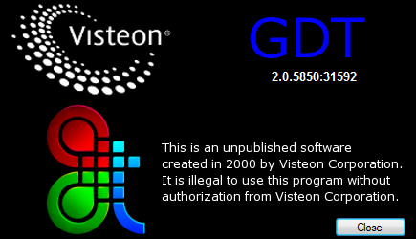

Language
- A language file could be configured in project settings.
- The SID_ language .xls sheet needs to be saved as a Unicode text file and set input to GDT.
- Language file is pared, and language menu is added in GDT.
- Current display language for text can be selected.

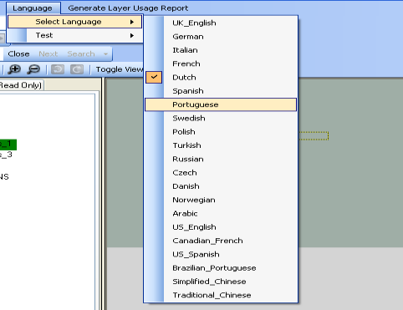
Select Language:
To select the language of the Test String and the same displayed on the GDT Viewer.

Test:
Test can be initiated to find out whether any text clipping will occur based on
Current configuration. Text could be run for a single language or all the languages.
Test will be run for all possible values for a text based on its configuration and checks, whether any clipping will occur or not.

It will generate Test string Truncation report in all languages and language wise.
This report contains

Truncation Report Number: 5
Language is: US_English
Sid is: 'Appear'
Font Name: Default_Font
Text name: New_texts_1
Concatenated String: Appear
Pixel width according to xml: 320
Pixel width for combination of Sid’s: 350
Pixel width exceeded by: 30

Generate Layer Usage Report:
Layer Usage Report: It will generate report with designed elements information
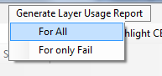
For All - Report Contains:
Combinations, Elements, Layers Needed, Result, Element List, State, Dynamic Element Childs, Overlapping)
For only Fail
For Kepler Platform if we designed more than 16 screens. Here expected screens
Only 16 but actual screens more than 16.Generated report for Fail

Note: It’s applicable only for DCU-Kepler1 Platform

Element:
Choose a particular element (Screen/text/Widget/etc.) you wish to view on the viewer. Type the object name to select or choose from the pull down list. And this shows the Currently Selected Element in the viewer
Not fully implemented only implemented switching between screens and widgets only in Tree view.

Highlight:
Used to change the outline color of the object (screen or Text) element.
Please find the below screens.
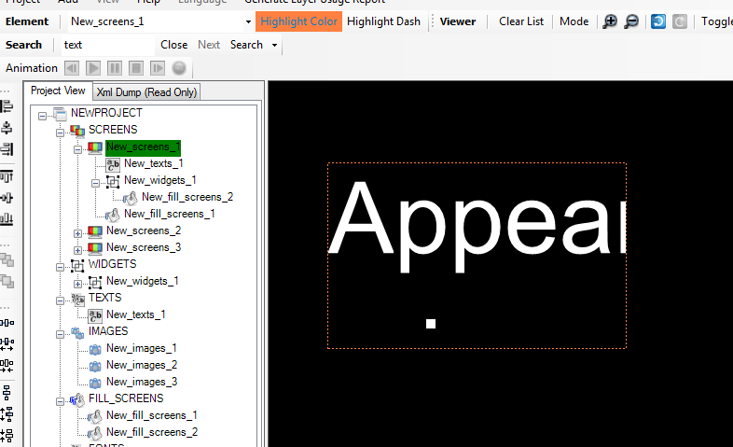
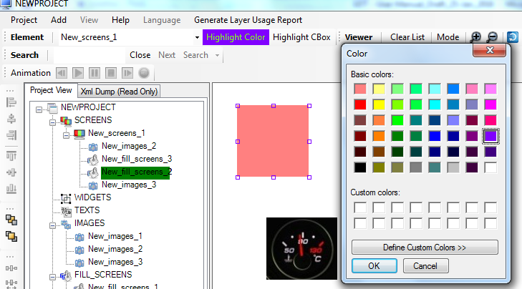
- Highlight CBox
Highlight the object outline as Box pattern
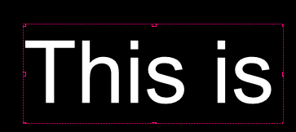
- Highlight Dash
Highlight the object outline as dash/line pattern
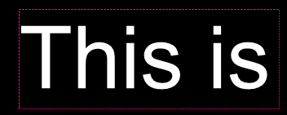
- Highlight off
Used for OFF highlight.

Search:
To search a particular element in entire design and the same displayed into arbitrator queue along with Path once found the element.

Clear List:
To clear the list of objects/elements in arbitrator queue. Arbitrator queue arranging the screen elements with priority wise.
Eg: 1. Three screen having different priorities.
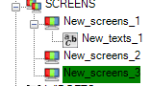
2. Display three screens at arbitrator priority wise
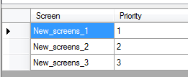

Mode:
Two Types of view modes are available
- GDT Property view Window displayed as horizontally
- GDT Property view Window displayed as vertically.

Zoom +/ Zoom –
- Zooms GDT Viewer display in 25% with step up to 500%
- Zoom Out the GDT Viewer display in 25% till up to 100%

Toggle View

Target View: Simulates how the objects will be appearing in the target
Normal View: Uses GDI Functions to perform all of the rendering so you may not get the exact appearance in Target due to difference in library used in Target.

Project Settings
To design a new project, proceed as follows:
- Click Project, and then click New.
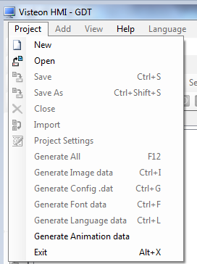

Layers: (Layer Configuration)
GDT opens the Project Setting Dialog as below.
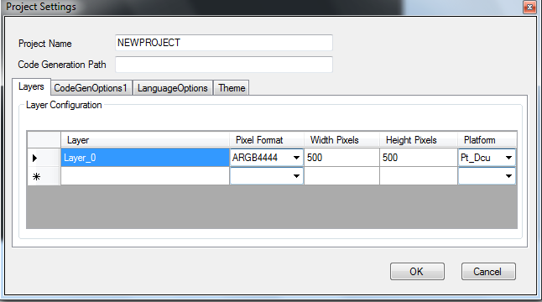

- Project Name : gdt xml Project name
- Code Generation Path: Specify the path where the code needs to be generated. You can enter a relative path i.e where you are going to save your project xml file or can specify a direct path
- Layer: It represents the actual target screen. We can configure more than one layer
- Pixel Format: Choose the Pixel Format as per your target LCD/TFT and Hardware.
- Specify the Width and Height Pixels of the display (Mandatory field for displaying GDT viewer and Target screen).It represents Target screen dimensions.
- Platform: Choose appropriate platform from the drop down list

Note: - Amber Platform can support only two layers.

CodeGenOptions1

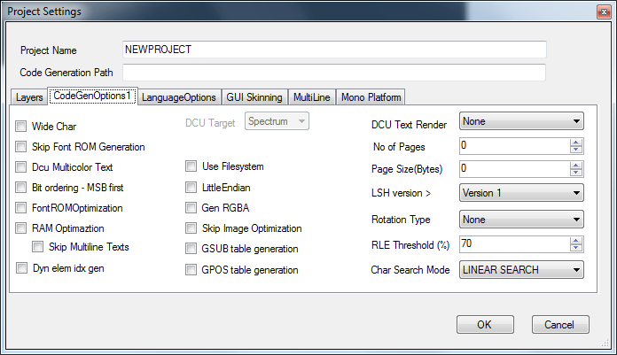
- Wide Char: To support Unicode char ranges is greater than 0xFF, then select this option so that the char length will change to 2 bytes instead of 1 byte.
- Skip Font ROM Generation: By default fonts generated along with code generation. Used for to skip the font generation at the time of code generation
- Dcu Multicolor Text: It’s applicable for only DCU Platform. It will be used for when we combine two different types of pixel format images into the one widget.
- Bit Ordering MSB First: By default bit ordering start from LSB. If we want to read memory values easily use this setting and as per the design use this setting.
- Font ROM Optimization: Memory arranged as pixel by pixel for fonts. If we want to optimize the unused memory area of font ROM use this setting.
- RAM Optimization: Generate RAM optimization report along with code generation. Used for optimizing the fonts and text memory.
Skip Multiline Texts: Ignore text elements with Line length > 1 while optimizing RAM.
- Dyn elm idx gen: Enable this option to generate indices of dynamic images/widgets as enum values.
- GSUB table generation: Enable this option, if project contains THAI language.
- GPOS table generation: Enable this option, if project contains ARABIC language.
- DCU Target: It’s applicable for only DCU Platform.
Spectrum: 8 bit aligned
Rainbow: 4 bit aligned
- USE File system: When set this option .bin files has generated autogen\gresfiles dir it will be used for changing the background image file on Target without flashing.
- Little Endian : Little-endian format reverses the order and stores the least-significant byte at the lower memory address with the most significant byte being stored at the highest memory address
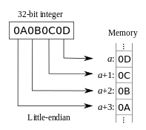
MSB -> Higher Memory address
LSB->Lower Memory address
Similarly w.r.t GDT also given strings has reversed while storing as its bytes.
- Gen RGBA : To generate the RGBA color space format instead of ARGB
- Skip image optimization: By default GDT occupy significant visual space for image optimization.
Image optimization Scenario:
Image1 size = 50*50
Image2 size = 200*200 it’s created by GDT.

When we want to represent image1 portion within the image2

- DCU Text Render: It’s applicable for only DCU Platform. Three types of rendering methods are available.
- CPU And DMA Render
DMA: Used for +ve set of values rendering
CPU: Used for –ve set of values rendering

So in CPU and DMA Render method -ve & +ve set of characters in the string will be rendering. If we use Arabic Lang characters. With this method will join the Arabic character for getting meaningful character

- Pre-render And DMA
-ve set of characters Pre-rendering done by GDT itself

- LSH Version: Logic State Handler – View Manager Version 2 using.
Version 1: View Manager 01 files will be compatible
Version 2: View Manager 02 files will be compatible

- Rotation Type : Image displayed be shown on the target clockwise – 90 Degree and anti-clock wise – 90 Degree direction

But this feature is not supported for Amber/Open_VG/Fujitsu platforms
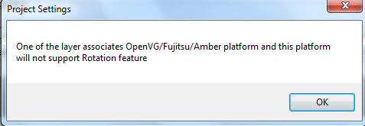

- RLE Threshold: Run Length Encoding (RLE) is a data compression algorithm. Here using for image data compression with configured threshold value. If it crossed configured value not required to compress the image data here setting 70% RLE. If
- In case where the amount of graphics data is huge, select the Page Size (Bytes) from the drop-down list.
- Here the page means the file, can split the graphics data into multiple files, and select the No of Pages from the drop-down list.
- Select the required Char Search Mode from the drop-down list:
- LINEAR Search: linear search or sequential search is a method for finding a particular value in a list that checks each element in sequence until the desired element is found. The list need not be ordered. It will be used when limited characters or there are no gaps in character code.
- BINARY SEARCH
The binary search algorithm begins by comparing the target value to the value of the middle element of the sorted array. If the target value is equal to the middle element's value, then the position is returned and the search is finished. If the target value is less than the middle element's value, then the search continues on the lower half of the array; or if the target value is greater than the middle element's value, then the search continues on the upper half of the array. This process continues, eliminating half of the elements, and comparing the target value to the value of the middle element of the remaining elements - until the target value is either found (and its associated element position is returned), or until the entire array has been searched (and "not found" is returned).It will be used when more characters

- - HYBRID SEARCH,
If the graphic library to decide dynamically, whether to do an LINEAR, or BINARY depends on how many split ranges are available in the given font.

Language Options

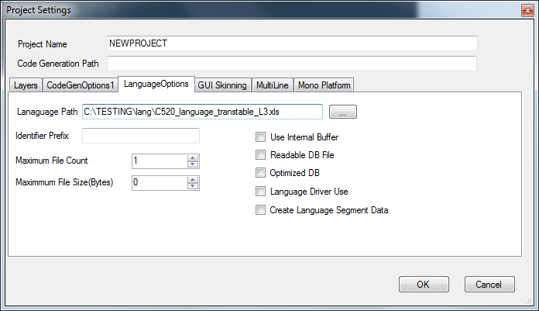
- Language Path: Select the SID_language file as an input.
- Identifier Prefix: This string will be used as prefix for the SID Identifier
- Maximum File Count: Generated file size can split into the no of files as we required.
- Maximum File Size (Bytes): We can split into the files w.r.t size.
- Use Internal Buffer: Reads and updates the string corresponding to pass SID in to internal buffer.
- Readable DB File: N/A
- Optimized DB: N/A
- Language Driver Use: It allows particular combinations of strings.
- Create Language Segment Data: N/A

GUI Skinning

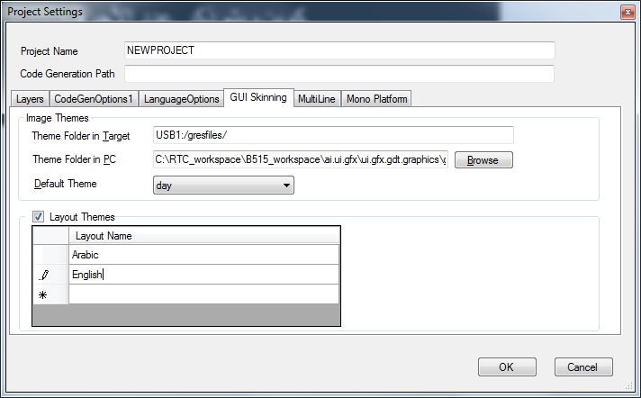

3.4.1 Theme settings
- Theme Folder in Target: Select Use File System from CodeGenOptions1 and select the gresfiles folder from USB (external device)/ generated code path.
- Theme Folder in PC:
Themes supported folder archive in the below path
..\..\ai.ui.gfx\ui.gfx.gdt.graphics\gdt.design\gdt.qt.resources\Resources\Theme support
- Default Theme: – Select theme (day/night).Based on the selection the background image will be changed.

3.4.2 Layout settings
- Layout Themes: Add the layout names in order as required.

Multiline
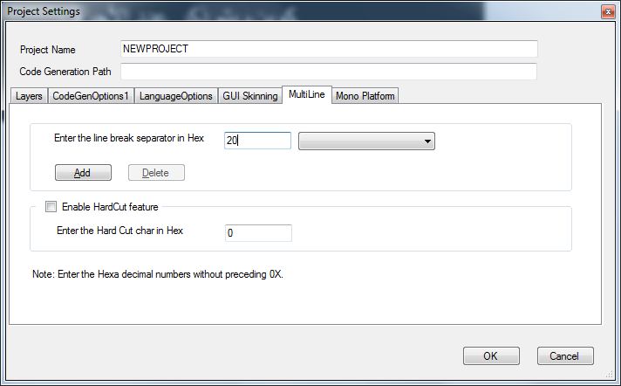
- Line break chars: Add/Remove the list of chars in hexadecimal for breaking multiline texts.
- Enable hard cut feature: Enable this option to split the word, if given text string not fit in textbox.
- Hard cut char: Enter the character (in hexadecimal) which will be appended at the end of words separated during hard cut.

Mono platform settings
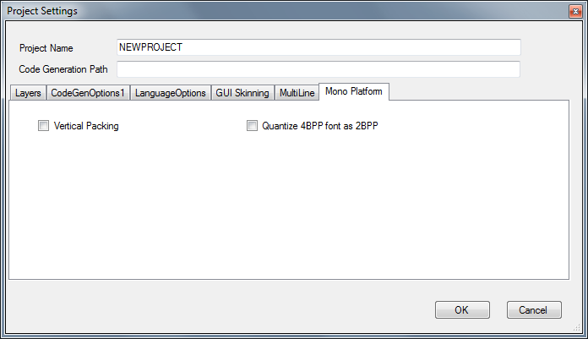
- Vertical Packing: Enable this option to generated image and font data in vertical.
- Quantize 4BPP font as 2BPP: Enable this option to quantize 4BPP font data to be generated as 2BPP font data (optional for Optimization).

Create And Save
Once you set the properties GDT displays the following pop-up message.
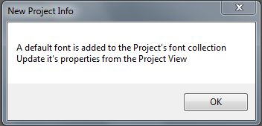

By default, GDT adds the default font to make it easier. At any time, you can modify or delete the default font.
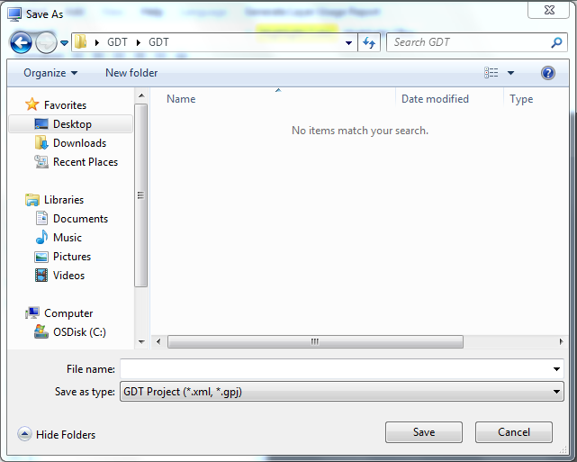

To Save the project, Click Project > Save or Project > Save As to open the Save As pop-up dialogue box. Select the save destination and enter file name for the project and click Save button. It will stored as XML format

Designing of Elements

Font Element
To design the font element, proceed as follows:
- Create New Project
- Add New Screen Element
- Add New Text Element to the screen
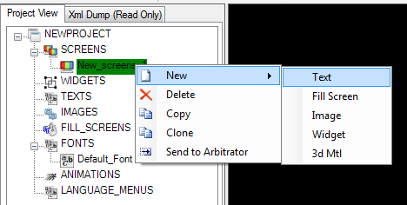
- Set Width Pixels its mandatory
- Displayed Text with Default Font on the viewer
- To modify font size
- Go to Default Font and configure the settings as per requirement.

About Properties:
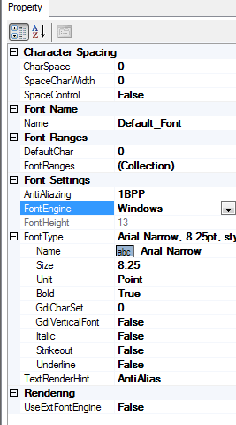
- Character Spacing :

- Char Space: Spacing between the Characters in Pixels.
- Space Char Width: The width of Space Character in pixels
- Space Control: (Enable /Disable) if set Enable changes will effect
Note(s):
- These changes are not effect from viewer side.
- We can see on the Target only.
- We can check via code generation.( hmi_gfx_mgr02_config.dat file and hmi_gfx_mgr02_cfg.h )

- Font Name:
- Type a meaningful name

- Font Ranges:
- Default Char: which is used by the target font rendering engine incase unsupported character is given for display.
- Font Ranges: To specify what character ranges need to be supported by this font element. Click on the collection to open the range dialog box.

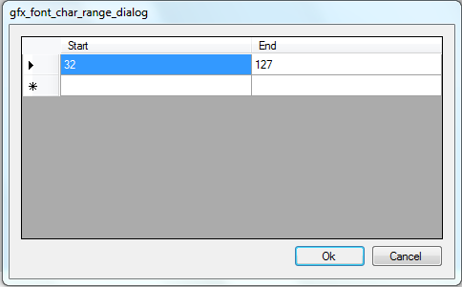

- Font Settings:

  - Anti Aliazing:
Smoothing the jagged appearance of diagonal lines in a bitmapped image. The pixels that surround the edges of the line are changed to varying shades of gray or color in order to blend the sharp edge into the background. This technique is also called "dithering," but is usually known as anti-aliasing when applied to diagonal and curved lines.

Choose whether the Font needs to be generated with Antialiazing levels or not
1BPP - No antialiazing.
2BPP - 4 level Antialiazed. Generates a 2BPP alpha map.
4BPP - 16 level Antialiazed. Generates a 4BPP
8BPP - 256 level Antialiazed. Generates a 8BPP
Alphamap. Needs double the ROM than 4BPP

  - Font Engine: Font engine for this font

- Windows
Whatever Properties having of “Default_Font” comes under Windows Font Engine. Its default font engine provided by windows.
- Free Type/ Monotype
If we select Free Type or Monotype third party font engines. We have to select corresponding font files then only we can see the text

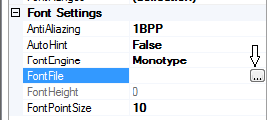
Note: Monotype font currently not supported for Mono platform.
- Font Type:
Click on the Font Type browse button to open the Font dialogue box. Click OK to configure the font
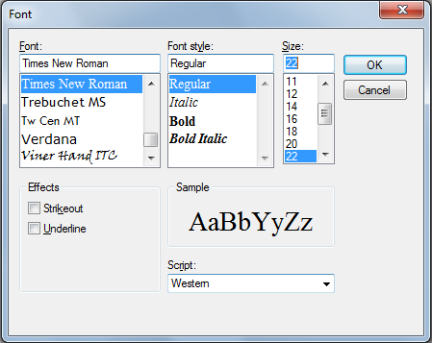
Change the FontType Size property until the requirement pixel is achieved.

- Unit: measurement in terms of units/Pixels/inches. Here using points only
- GdiCharSet: Gets a Boolean value that indicates whether this Font is derived from a GDI vertical font.
- GdiVerticalSet: TRUE/FLASE

- Rendering
UseExtFontEngine (TRUE/FALSE):
External font rendering option by default it is FALSE. It means GDT with the help of Font Rendering engine (Windows/Freetype2/Monotype) generating input data as a bitmap each char and the same used for executing on the Target since Target is not having the font engines. If we set TRUE then the Target is having Font engines.

- TextRenderHint:
Text Rendering Hint for this font
1. In Default Font set the font size 400pts and checks the text by changing each setting of TextRenderHint.
To enhance the font element, proceed as follows:

Font Group
- GDT Support to create a Font Group:
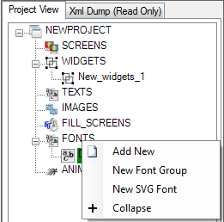

  - Font group is a collection of fonts similar to a dynamic image.
  - User can set the font to be selected at run time.
  - A text can be configured with a font group.
  - Based on the user selection, the text gets rendered with chosen font.
  - Allows the user to display a text in multiple fonts one at a time.
- How to use Font Group:
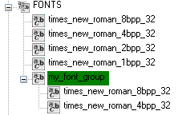

  - Right-click on Font folder.
  - Select the New Font Group from the menu list.
  - A new font group element is added.
  - Drag and drop the fonts into the created font group.
  - Select the same font used in Text element font id from font settings
- How to use New SVG Font Group
Note:
This feature not supported.

Screen Element
To design Screen elements, proceed as follows:
- Basic Screens element can be created in the following ways:
- On the project tree view, locate the screen element container and right-click

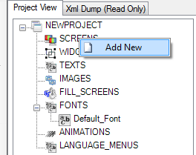

- This will open a context menu
- Click on the “Add New” menu item
- This will add a new Screen element
To configure the element, proceed as follows:
- Basic elements will always be created with an auto generated name. (here New_Screen_1)You want to rename it with the corresponding name based on what you are designing or what the element represents. For example, if the text element is to display odometer, then it will be ideal to name it as the txt_odometer.

- Two different ways to rename the element.
- Double-click the element and rename it
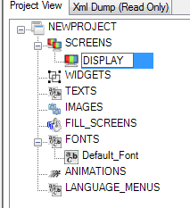
- Click the element to start it and the property window “Name” enter the appropriate name
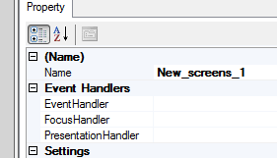

- Elements are created with the default properties.
- You can configure this according to requirements.

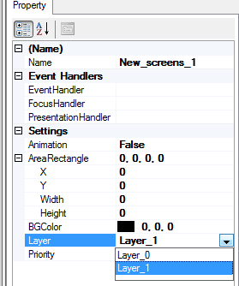

Event Handlers:
Event handler:
Specify the Function to handle user events. On the GUI side, events include key strokes, mouse activity, action selections, or timer expirations.

Focus Handler:
Specify the function to handle the focus change. Eg: Screen_1 having priority 1 so it should be displayed at top most. When the same screen priority changes to 0.Focus handler has to show the screen which is having 1 priority (highest priority) and when screen is active same time pop up message appears.

Presentation Handler:
Specify the function to handle the presentation for this screen. To fill up all the dynamic information such as odometer and track timer etc.

Main States

LSH_DEACTIVATED_STATUS - Indicates the logic state is deactivated
So presentation can send commands to remove associated screens.
LSH_ACTIVATED_STATUS - Indicates the logic state is activated so presentation can send
commands to activate associated screen and its content.

LSH_REFRESH_STATUS - Indicates a refresh command Presentation can use this to send only
the Changed

Settings

Animation: (TRUE /FALSE): Once animation enabled its properties are stored in RAM and its properties can be changed at run time
Layer: We can configure screen element for Layer_0 or Layer_1 etc (Two Layers only assumed)

Priority: Based on this priority value screen will be displayed on the Target.
Eg: Priority = 1 Screen having high priority appears Top most

Area Rectangle: Display area for this screen.
BG Color: It represents the background color of the screen

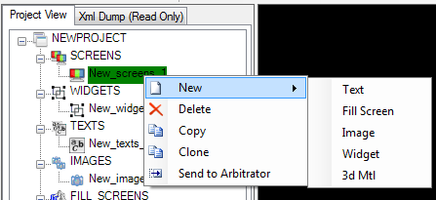
We can add Text, Fill Screen, Image, Widget and 3d Mtl (3D Not Implemented) elements for each screen
Note(s)
- Screens are the highest level of group elements, which contain all the basic elements, widgets (Dynamic and Static) and Dynamic Images.
- Screen cannot contain another screen.
- Screen represents one layout.
- Screen has mainly two properties:
  - Layer – Which hardware layer the layout needs to be built
  - Priority – It says in a layer which priority order the layout need to be placed or simply specifies the building order. So a screen with priority 0 will be built first and Priority 1 screen will be built on top of priority 0

Widget Element:
To design widgets, proceed as follows:
- Create New Project
- Add New Screen Element
- Add New Widget Element to the screen
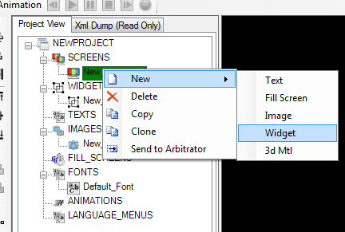
About Properties:
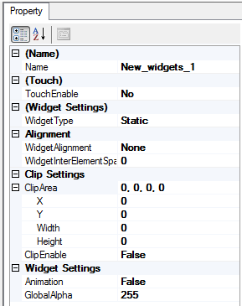
- TouchEnable: By Default No if choose yes the widget would be touchable/Press on touch screen.
- Widget Settings-> WidgetType, select Static or Dynamic.
If we select Dynamic change the properties at run time

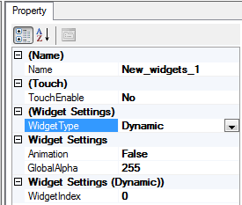

- WidgetAlignment, as per the need select Left, Center, Right.
- Widget InterElementSpace: Specifies the in Pixels to be inserted between elements while performing alignment
- In ClipArea, select as per the need for a static content need clipping to a rectangle use this.

Note: After creating a widget, you can also drag and drop the elements into the widgets.
- After dragging appears as below

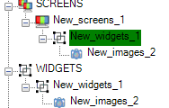

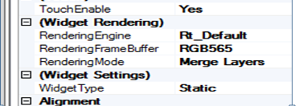

- Rendering Engine (Rt_Default/Rt_OpenVG/Rt_Software)
By default Rt_Default. If we set Rt_OpenVG the transform properties tab will be displayed.

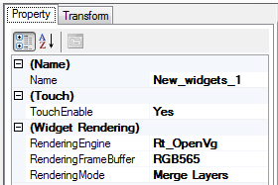

- Rendering mode: Merge Layers and Keep Layers
Merge Layer:
If we select Merge Layer, Whatever we added Images and Text elements under widget element will be combined (merged/clubbed) stored in Framebuffer and the same representing as a single layer. In case of Keep Layer each element will be represented as each layer.

OpenVG Property Tab
To update the transform properties tab, proceed as follows:
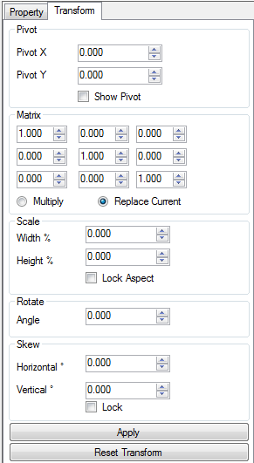

- In order to set OpenVG transformation properties tab is added
- Tab will be visible only for OpenVG elements
- If rendering engine mode set Rt_OpenVG for widget it will be displayed
- With this transform tab modify the properties of the image and Text element corresponding widget
- Tab provides editing for:
  - Pivot point for transformations
  - Transformation matrix
- Currently only keyboard based editing only is supported for OpenVG transformations

The below sample designed screen for reference - developing widget element:
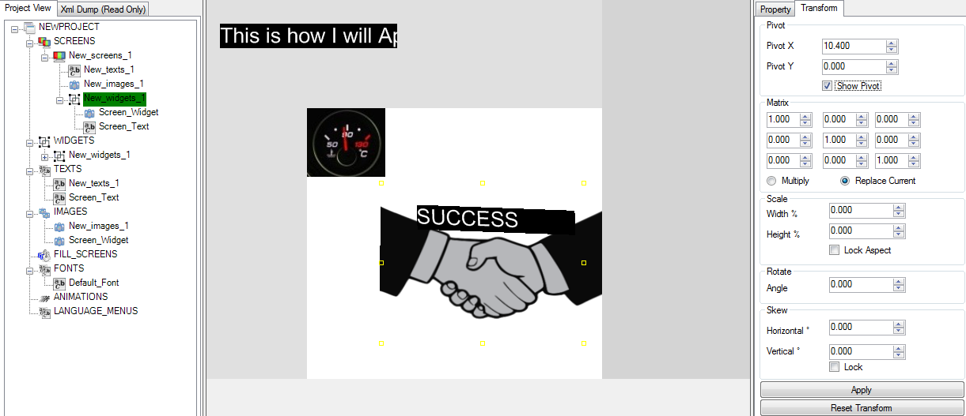

Image Element
To configure image element, proceed as follows:
- Create New Project
- Add New Screen Element
- Add New Image Element to the screen
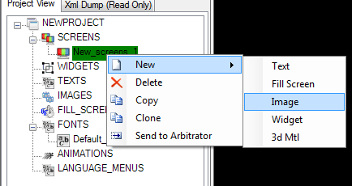
Or
Upload another way
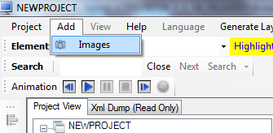
- Upload BMP Image file (It can support png and bmp format only)
Not supporting svg format file

About Properties:
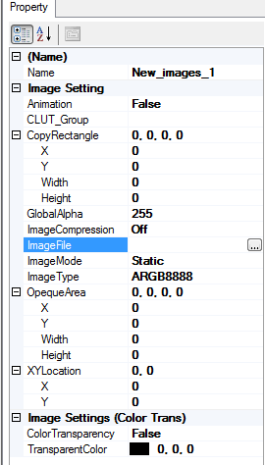
Image Setting:
- 1 .Animation: If its enable modify image properties at run time
- CLUT_Group
CLUT Group – This setting is only valid for indexed color Image Type. This specifies the name of the Color Look-Up Table group. If specified, GDT will generate a single CLUT for all the images with same CLUT group name. Leave it blank if a separate CLUT needs to be generated for this image. If no CLUT needs to be generated, specify NO_CLUT. By specifying NO_CLUT, GDT will also not generate the image data. (Note that when grouping different images, we need to make sure that all the Image Type are equal.)
- Copy Rectangle: If we want to select particular portion of the inserted image.
Set copy rectangle dimension values. (As like crop feature)
- Image Compression: select the required image compression for the image.
Below are the compressions methods are using
(SwRLE/HwRLE/Jpeg/Off)

Jpeg:
JPEG has a big compressing ration, reducing the quality of the image, it is ideal for big images and photographs.
RLE:
Lossless data compression method

- Image File: Select an image to be displayed. Click the browser button and select the image to be uploaded. Note: Image file should be placed in the same or child directory where the design xml is placed. Then the image file path is taken as a relative path automatically. Place the file in the same folder on in the child folder (.png, .bmp files can support).

Note:
It’s not supporting .svg image files

- Image Mode: (Static / Dynamic)
If we select Dynamic: The below properties only displayed and we can change the settings at run time.

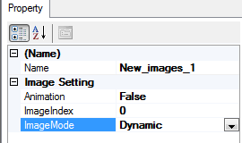

Image Index: Selected image index for the dynamic image at run time.

- Image Type: select the type image from the drop-down list.
By using this we can convert the image format while displaying on the Target

- Image Settings:
- Color Transparency (TRUE/FLASE) : Set TRUE changes will effect
- Transparent Color: Change the background color of the inserted image.

Text Element
To design text element, proceed as follows:
- Create New Project
- Add New screen
- Add New Text Element to the screen
- Modify width pixels (eg:100) Its mandatory
- If we want increase font size change font size in font settings of Default Font

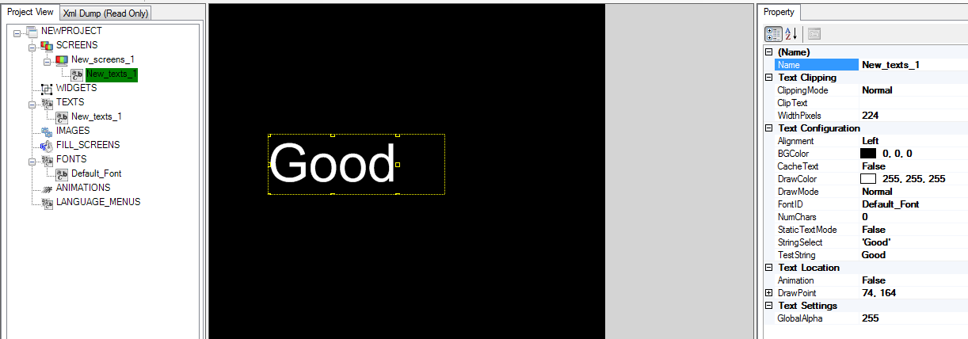
- Text element is used to display the static or dynamic text information on the display such as: Odometer or Radio frequency

Properties:
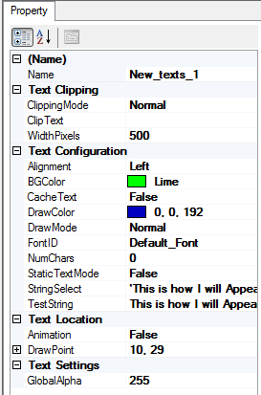
- Name: This is used later in the presentation code to interact with this element.
- Text Clipping:
- Clipping Mode:
Chooses the Clipping Mode (Normal/Append/Text Fit)
- Normal Mode:
- If the given TestString exceeds by increasing its font size the available width clipping width Pixels following appears below:

Before increase Font size
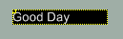

After increase
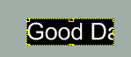
- Append Mode:
- If the given TestString exceeds by increasing its font size the available width clipping width Pixels following appears below:

Going to add clip text
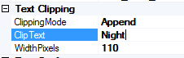
Resultant will be appears as below
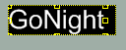
- Text Fit Mode:
- If the given TestString exceeds by increasing its font size the available width clipping width Pixels following appears below:
When changing into Text Fit Mode the same screen will be appears below
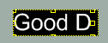
I.e. Exact fit text only appeared.
WidthPixels: Specify how much width can allocate in pixels. Mandatory field, otherwise it
Will display anything in the target.
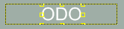
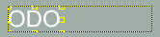
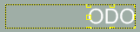
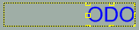
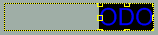
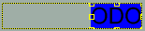
In Text Alignment: This is used to align the text as per requirement.
Background is transparent
Background is BGColor

- Clip Text: (TRUE/FLASE)
If we set TRUE char caching and FLASE – String Caching
Text Configuration
- NumChars: To specify the number of char of the text used for RAM buffer allocation. Mandatory field, otherwise it will display anything in the target.
- StaticTextMode: If False – Text buffers in the RAM and can be changed during the run time. If True – Text buffers in the ROM and cannot be changed during the run time.
- DrawPoint: XY location for the text element.
- Cache Text: To avoid multiple times the build of the same string cache text will be used. If it’s TRUE only one time build the string and placed at buffer and used without build directly the same whenever it’s required.
- String Select
    - Sample String to be displayed in viewer
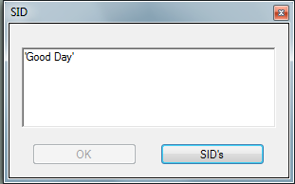

For Get more string indexes
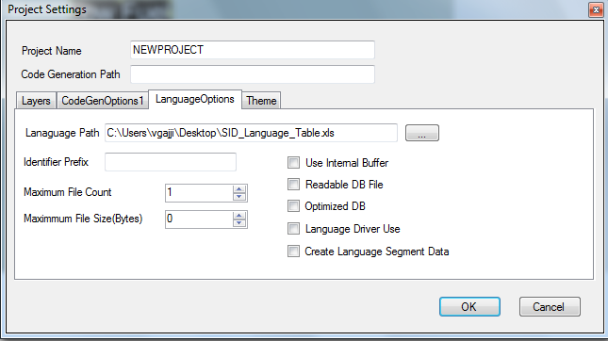

Select SID_Language_Table.xls sheet under Language Options in Project Settings.

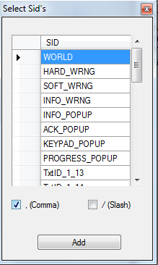

- Test String :
Sample selected Text to be displayed in viewer
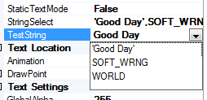
Text Settings
- Global Alpha :
Enter a value here (from 0- 255). 255 is Opaque and 0 is fully transparent.

Another important property of a text element is which font and setting need to be used to display it.
- In our cases, customer will be provided with the font files and its height requirement.
- You can first create a font element, to assign a font to a text element.
- To add the new font to the FONTS container, follow the basic element creation techniques.
- Do not specify the created new font element and its properties.
- You can view the newly added font elements in the drop-down list of the text element FontID property. One thing to remember is that you don’t need to create a font element for every text element. You can reuse the font element for the text element when, if the font configuration doesn’t change.
- See the below screen
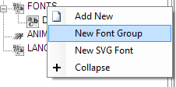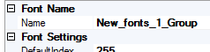
After Adding “New Font Group “That same group set for Font ID see the below screen

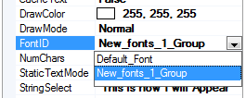

Note(s):
- Only Font elements can be added into Font Group.
- Default Font and Font(s) added via drag and drop to New Font Group (Group).
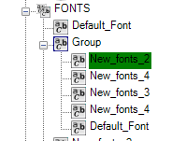

Fill Screen Element
To design fill screen element, proceed as follows:
- Create New Project
- Add New Screen Element
- Add New Image and Fill Screen to the screen
- Upload supported image file
- Click on Fill Screen element do the required settings as below
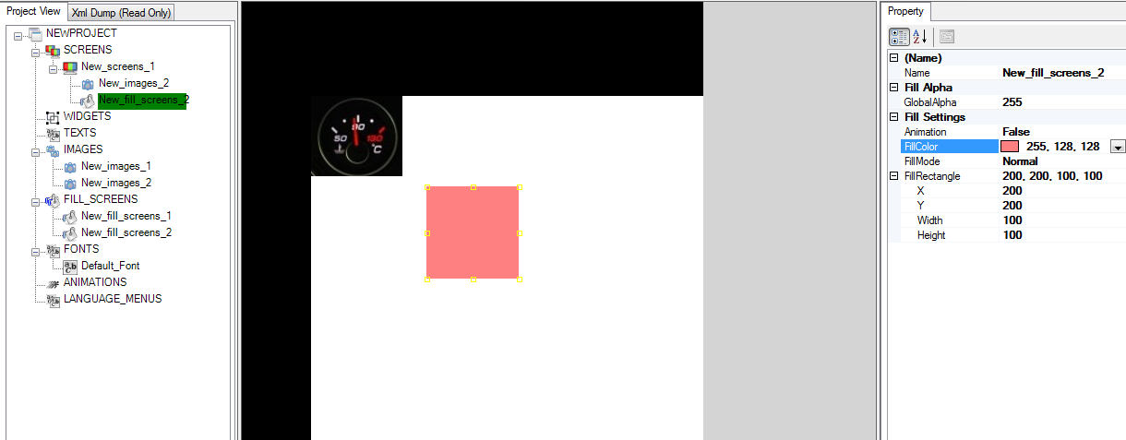

About Properties:
- Fill Screen Element will be used for two different purpose:
- Fill a rectangle area with color
- Fill a rectangle area with a given image (called as pattern fill or tiling)

- In Animation, select True to modify the fill area during run time.
- In FillMode, select the fill mode either: Normal, Tiling
- In Fill Rectangle, choose the fill rectangle X, Y, Width, and Height.
If we set Fill Mode is Tiling the Pattern Fill Image will be enabled.
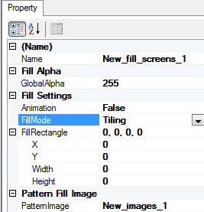
Select pattern image and the entire fill rectangle is filled with the selected pattern image
- Normal Mode
In Normal mode the entire rectangle is filled with a single color chosen in the FillColor property.
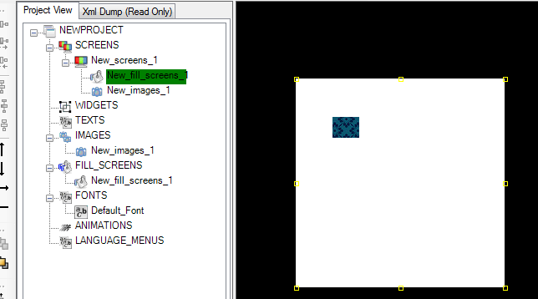

- Tiling Mode
In tiling mode, the entire fill rectangle is filled with the specified image element in the Pattern Image property.
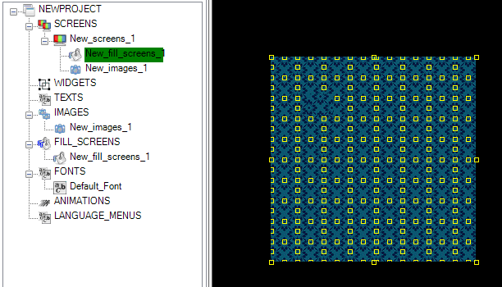

Animations
Application call back: To be invoked during start of every frame.
To design animation proceed as fallows
- Create new project
- Add new screen element
- Add widget element
- Add new image and text element to the widget(User_Widget)
- From Project view add new animation

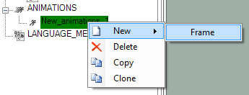
- Add new animation frame
- Use the below animation settings

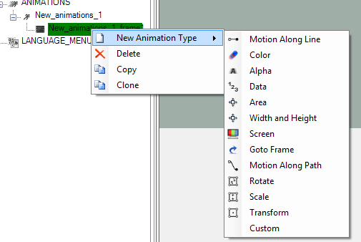

- Select one of the animations type (select Alpha)
- Drag and drop User Widget under New_alpha1 which was created before
See the below screen
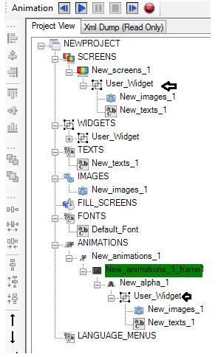
Once done as per the above configuration just run the animation.

Various types of animations and its usage:
- Motion along Line:

- Create Text Element
- Drag and drop to animations frame
- Configure as per the below screen run animation
- Set offset XY positions
- Added Text will be moving linearly i.e. along a line from origin (0, 0) to specified positions (100,100)
- Please check the below screen for your reference

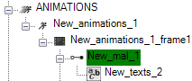

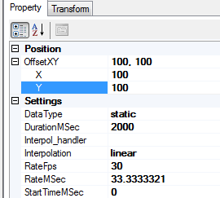

- Color
- Design Text Element
- Add color animation to the animation frame
- Drag and drop the text element to the color animation frame.
- Set the start and End Color then Run animation
- Text displayed on the GDT viewer starts with “StartColor” and end with “EndColor” as we specified.
- Please check the below screen for your reference.

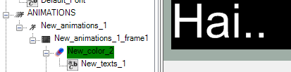

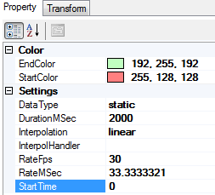

- Alpha
- Design Image element
- Add alpha animation to the animation frame
- Drag and drop image element to the alpha animation
- Set the start alpha value as 0
- Run Animation
- Image will be displayed on the viewer from transparency to complete image
- Please check the below screen for your reference.

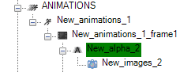

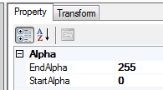
Alpha =0 ->
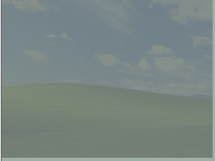

Alpha =255 ->

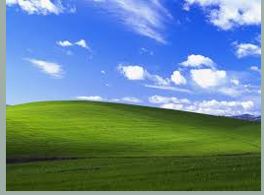

Screen slowly appeared

- Area
- Design widget element
- Add image element to the widget element
- Set the clip are for widget
- Add area animation to the animation frame
- Drag and drop the widget element into the Area animation frame
- And set the new are offset values, DurationMsec then Run the animation
- Image will be view on the GDT viewer as per the settings

- Width and Height
- Design widget element
- Add image element to the widget element
- Set the clip are for widget
- Add width and Height animation to the animation frame
- Drag and drop the widget into the animation frame
- And set the new are offset height and width values to the animation frame, DurationMsec then Run the animation
- Image will be changed on the GDT viewer as per the settings

- Data
- Design widget element
- Add image/Text element to the widget element
- Add Data animation to the animation frame
- Add the widget into the frame
- And set the new start and end data values, DurationMsec then Run the animation
- Image/Text will be view on the GDT viewer as per the settings

- Screen
- Design the Screen1 and Screen2
- Add Text element for each screen
- Add New Screen animation type to the animation frame
- Drag and drop the Designed screen element1 and element2
- Please check the below screens and run the animation
- Screens moving as per the sequence

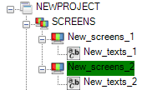

- Drag and drop Screen1 and Screen2 as per the below screen
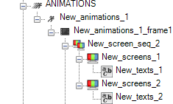
- Run the animation

- Go to Frame

- Configure as per the below screen

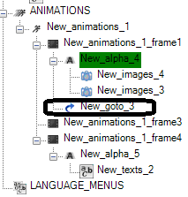
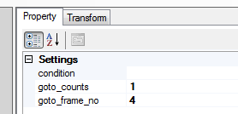

Add condition and based on that run animation frame 4.

- Motion along Path
- Design an image element
- Add Motionalongpath animation to the animation frame
- Add the image into the animation frame
- And select motion path contain obj file (svg ), DurationMsec then Run the animation
- Image will be move w.r.t the path.

- Rotate
- Design an image element
- Add Rotation animation to the animation frame
- Add the image into the frame
- And set the rotation angle, DurationMsec then Run the animation
- Rotate screen/Text element animations clockwise and anti-clock wise direction

- Scale
- Design an image element
- Add Scaling animation to the animation frame
- Add the image into the frame
- And set the scaling factor values –ve or –ve values, DurationMsec then Run the animation
- Rotate screen/Text element animations clockwise and anti-clock wise direction
- Scaling will be processed as per your setting

- Transform
- Add the text element into the animation and set the Transform matrix values
- Run the animation
- Image/Text will changes on the GDT Viewer as per your settings
Note:
- Custom animation same as Alpha animation both functionality same.
About Properties
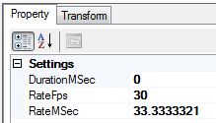
- New_animation_frame_1

- DurationMsec: Animation Frame duration
- RateFps (30/60) as per requirement : 30fps/60fps
- RateMsec :Frame rate in milliseconds

- Interpolation
Interpolation is a method of constructing new data points within the range of a discrete set of known data points.

Note(s) about elements usage
- GDT Supports cloning feature:
Right click on the element and select the "Clone" context menu. This will create a new element with the same properties as the cloned element but with a unique auto-generated name.
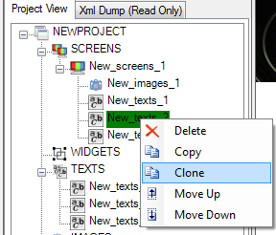
- We can select multiple elements also
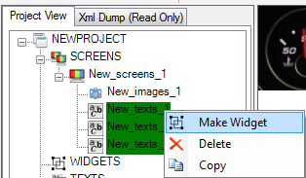

- Select the element you wish to move and drag it by keeping the left mouse button down. Drag it to the desired element and then release the left mouse button

- Select the element you wish to move by clicking on it.Right click to bring up the context menu and select the "Copy”. Now select the targeted element and right click. Select "Paste" from the context menu. You will see that the copied element is placed in the target element.

Language Menus
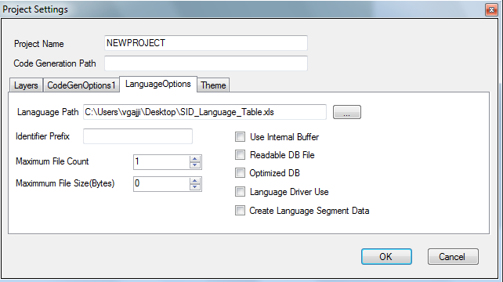

- A language file could be configured in project settings
- Add New Language Menu at Project view and select fields see the below screens

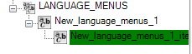
- New_Language_Menu_1 will be added into context menu
- Go to properties and select text id
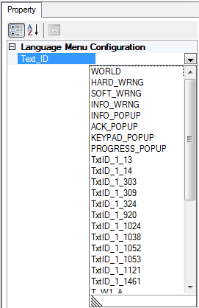

- Add language menu item to the language_Menu_1 context menu
- Select the language

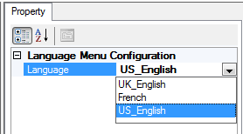

Language Support
To initiate the language support, proceed as follows:
- A language file could be configured in project settings.
- TheSID_ language .xls sheet needs to be saved as a Unicode text file and set input to GDT.
- Language file is pared, and language menu is added in GDT.
- Current display language for text can be selected.

- Also test can be initiated to find out whether any text clipping will occur based on current configuration.
- Text could be run for a single language or all the languages.
- Test will be run for all possible values for a text based on its configuration and checks, whether any clipping will occur or not.

Using SID’s in Text
To use SID’s in Text, proceed as follows:
- Click StringSelect property to open the SID editor.
- Either type in SID or Click SID’s button to open the list.

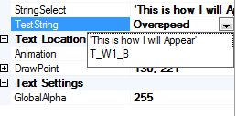
- If the text box needs to display multiple lists of SID’s then separate the list with ‘/’.
- If the text box needs to display one list at a time, then separate with “,”.
- Select the required SID list from the drop-down list.

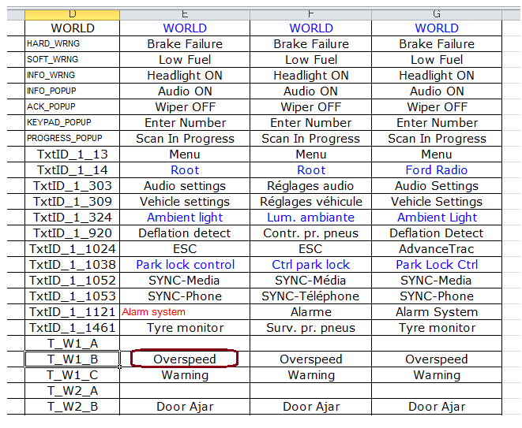
- Numeric value and static string also can be specified.
- Following are the supported items:
- SID
- Static String – enter in single quote
- Dynamic String – enter Y for every character for e.g., for length of 4 use YYYY
- Numeric Number – enter as XX.XX, use Z to hide leading zero.
- XX.XX > 00.00 to 99.99
- ZX.XX > 0.00 to 99.99

Other

Grouping Elements
To group the element, proceed as follows:
- In order to provide more functionality for easy visual representation, reuse the GDT group elements:
  - Widgets
  - Dynamic Widgets
  - Dynamic Images
  - Screens
Widgets are collection of Basic Elements
  - Dynamic Elements
  - Widgets
  - Dynamic Images
- Dynamic Widgets is a collection of Widgets, and you can select one of them during the run time. This allows switching between different contents.
- Dynamic images are a collection of Static and Dynamic images, and you can select one of them during the run time. This allows switching between different images at run time.

Dynamic Image
To create dynamic image, proceed as follows:
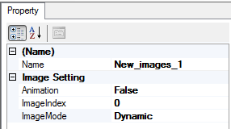
- By default, the child element of the dynamic image will be displayed at the programmed location of the child image.
- If the DynamicXY property of the dynamic image is set to True to the above behavior will be changed. The child images will not get displayed at the XY location of its parent dynamic image. Moreover, you can change the XY location during the run time.

Selecting Rotation Types
To select the rotating type, proceed as follows:
- TFT will always be in landscape orientation.
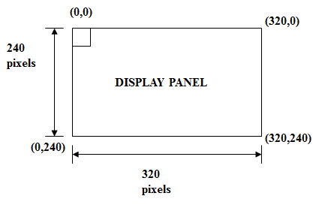
- Frame buffer memory can be visualized as starting from 0, 0 till 320, 0 and then repeats similarly till 320, 240.
- If the TFT placed in the portrait orientation in the hardware.
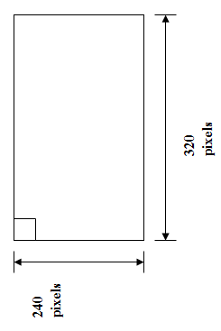
- GDT always scans the screen info and generate the data in the order to be written in the framebuffer.
- Normally DMA is used to transfer the graphic content from Flash to framebuffer.
- Now with the orientation change DMA cannot be used since the destination address in the framebuffer is not sequential.
- This leads to redundant load on the CPU to transfer the content into framebuffer.
- So the idea was to make the change in the code generation of GDT itself.
- Clockwise rotation – The pixel data is read from the top right corner of the element in the vertical direction.
- Anticlockwise rotation – The pixel data is read from the bottom left corner of the element in the vertical direction.
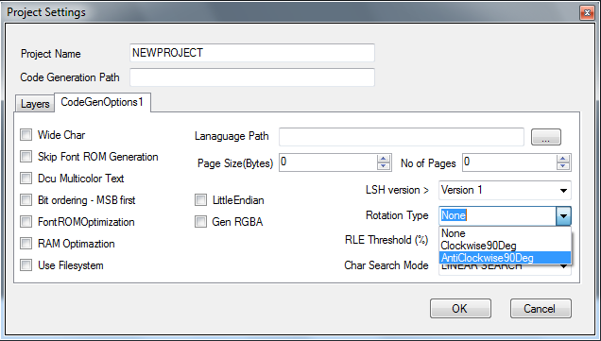

Text Rendering

To render the text, proceed as follows:
- Text consists of character which is taken from the font library. So each character can be visualized as a bitmap again
- Font generation is not modified so the text rendering is not done through DMA right now
- The change is done in the graphics driver with the pixel data in character copied to the frame buffer
- The next pixel is rendering after decrementing the frame buffer in case of clockwise rotation and incrementing the frame buffer by the WIDTH of the display in case of anticlockwise rotation
- Text clipping, start offset, end offset to be taken care while modifying the frame buffer

Platform Specific - Kepler2 (Pt_Amber):

For designing the graphics for Amber Platform, select Pt_Amber in Platform drop –down list in Project Settings of GDT – Layer Configuration

Layer Configuration:
Layer0:
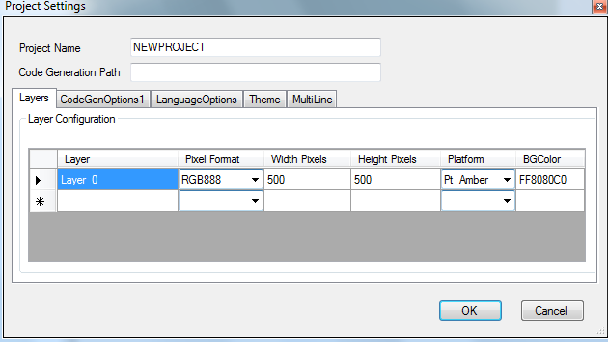
BGColor: The Background color for the Display Controller can be Selected in this column and it can be modified at runtime using the below API.
void hmi_gfx_mgr02_amber_set_disp_bgcolor(UINT8 p_disp_index_u8, UINT32 p_bg_color_u32)

Dual Display configuration:-
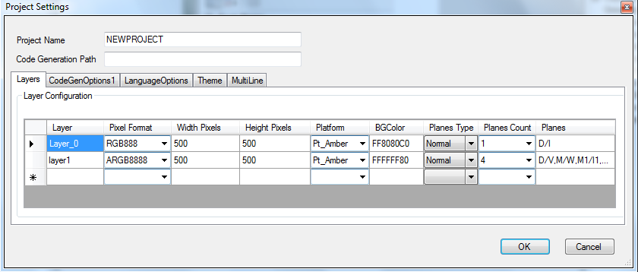
For dual display, the below options will be available for configuration.
Assign the specific feature for the Display Controllers depends on the requirement and configure the Plane Types with respect to that.

Planes Type:
Normal: Generic setting and there is no specific hardware functionality got selected like
Warping, Video Decode.
Warp: It supports Warping Feature (for example, Head up Display).
Video: It Supports Video decoding Feature (for example, Car Rear camera).
Planes Count: Used for Selection of planes count in the combinations of (1, 4) (2, 3) (3, and 2)
(4, 1) for layer 1 and layer2. Since Total planes (Fractional + Integral Panes) should be 5 only.
Planes:
    - Decode(D/I): This plane supports decode and Index feature
    - Decode/Video (D/V): This is plane supports video decoding capability.
    - Warp (M/W): This plane supports Warping feature. If the Warping feature is not used means, it will be used as Fractional plane without direct rendering of indexed image support.
    - Multi (M1/I1): Fractional Plane with Indexed image support.
    - Multi (M2/I2): Fractional Plane with Indexed image support.
Notes:
- Select the planes equal to the number of Plane count.
- The selection of same planes in both the layers not allowed.
- There are no restrictions on selecting planes for normal plane type.
- If Plane type is Warp/video, then it is expected to select the appropriate planes.
- Pt_Amber platform can be allowed up to 2 layers only.

Design Rules:-

  - The Hardware has 2 Display Controllers. So, the Layers in the Layer Configuration mapped with that. The available 5 planes can be shared between the Display Controllers.
  - If only one layer is configured, then the all 5 planes are assigned to that.
  - There are 2 - Integral planes and 3 - Fractional Planes are available in the Hardware.
  - The Fractional planes have 8 sub windows/layers each.
  - The screen’s root elements are treated as planes in GDT.
So, It is expected that the design to have maximum 5 root elements active at any time.
  - The keep layer widget element is mapped to hardware’s fractional plane.
So, it is expected to have maximum 8 active elements only in that.
The overlapped keep layer widget elements are displayed as opaque. The higher element pixel at top is the resultant pixel of this widget. This pixel at top will be blended to its lower Root elements with its element resultant alpha.
  - There are 2 planes support the decode feature. So these two planes can be used to render the compressed images without pixel engine.
  - The Merge widget elements are rendered using the pixel engine. It uses VRAM to store the rendered elements. Ensure the RenderingEngine selected as Rt_Default in Widget Rendering property and make either the Animation =TRUE or Clip =TRUE.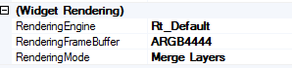
  - The transformation of elements can be done with pixel engine.
So, make sure the element which you want to apply any matrix operation is with in merge widget.
  - The transformation functionality (such as rotation, scaling, mirroring,…) can’t be done with compressed images.
  - The direct rendering of the compressed image from Keep Layer is not possible.
  - There are only 2 fractional planes out of 3 supports indexed image rendering.
There are some CLUT sharing techniques included with it.
  - There are 3 compression methods (RLE, RLA and RLAD) supported in Amber platform.
The Auto option in this select the best option among the lossless methods (RLE and RLA) in terms of memory saving.
